<Insert Your Name and Class>

IT Online Training (ITOT) Analysis Specification

1. Introduction
This document is a record of identified requirements for IT Online Training system. All classes, functions, procedures, and attributes required for implementation of this system is recorded. Each section contains detailed information describing workability of the target IT Online Training system.

1.1 Problem Description
Learning new skills has become one of the most demanded things in the modern world. This demand is not met as there are limited physical learning institutions that everyone can attend. Also, time is another factor that makes it hard for people to go to school to learn. With modern technology, online classes have become very popular though in most cases, not everything is done online. There is a need to have a fully functional online training system, where everything is done online.

1.2 Sponsor Project Description
For someone to join the online class, one has to be convinced that the system used is reliable and convenient. The problem of limited time to attend classes can be eliminated if our proposed IT Online Training System is implemented. The learner should be able to choose the course of their choice and access resources related to that course. Also, payment should be done within the system and also certification. The challenge of attending physical classes is so real and need a solution.

1.3 Sponsor Requirements

The sponsors of the project have identified some preliminary requirements of the system as documented below.

The following are some initial requirements of the application.
Functional Requirements
1. Purchase ITOT Products
REQF1.1 Customers must be able to purchase ITOT Products via an online shopping cart.
REQF1.2 The Customer must be able to add and remove products from an online shopping cart.
REQF1.3 Customers must be able to cancel orders.
REQF1.4 Customers must be able to purchase by credit card.
REQF1.5 System must provide certificates of completion for customers.
2. Maintain Customer information
REQF2.1 Customers must be able to create and change customer account which holds information about the Customer including customer id, first and last name, address, phone numbers for work and cell phone. Customer id is issued by the system and cannot be changed by the customer.
REQF2.2 The system must be able to store and maintain customer credit card information for each credit card including account number, account name, expiration date, and security code.
REQF2.3 The system must maintain a list of accounts in its central database.
REQF2.4 The system must be able to search and display customer information by instructors, course administrators, schedule administrators, and other administrators
3. Maintain Products
REQF3.1 The system must be able to create, modify, and delete ITOT Products including scheduled courses, self-paced courses, videos, and books.
REQF3.2 The system must be able to maintain course information including course number, course title, course description, course type, course duration, course start date, course end date, course prerequisites, CEU credits, and course fee.
REQF3.3 The system must be able to maintain video information including video id, video name, and video fee.
REQF3.4 The system must be able to maintain book information including title, authors, date, edition, and ISBN.
REQF3.5 The system must maintain course history including offering dates (beginning and ending), number of students enrolled, and instructor.
REQF3.6 The system must provide search capability for courses based on title, category, popular course, recent releases, planned courses.
REQF3.7 The system must provide access to all course maintenance features to the Course Administrator.
4. Maintain Instructor Information
REQF4.1 The system must maintain Instructor information including instructor id, instructor first and last name, address, cell and home phone, areas of teaching expertise, bio, and stipend.
REQF4.2 The system must be able to provide reports of instructor schedules and courses taught
5. Maintain Course Schedules
REQF5.1 The system must be able to create, modify, and delete course schedule information in its central database including course title, course number, course description, course prerequisites, course type, length of course, course outline, schedule dates, and instructor information.
REQF5.2 The system must be able to query course schedules and display results for all users based on keyword, title, and schedule.
REQF5.3 The system must provide all course schedule maintenance features to the Course Schedule Administrator.
6. Manage Shopping Cart
REQF6.1 The system must be able to provide a shopping cart feature for customers to select and pay for courses.
REQF6.2 The system must provide a Shopping Cart Item which lists each item in the Shopping Cart including quantity, item number, item name, cost, shipping, coupons, discount, and total.
REQF6.3 The system must be able to provide customers with the ability to update the shopping cart including increasing the number of items, removing items, calculating shipping costs, and applying coupons and discounts.
REQF6.3 The system must be able to provide payment options for the customer including credit cards.
7. Access Credit Card Service
REQF7.1 The system must be able to link to an external Credit Card Service.
8. Access the Accounting System
REQF8.1 The system must provide a link to the Accounting System for the transfer of customer payment information.
9. Provide User Management
REQF9.1 The system must provide management of User with user name and password for all users of the system including customers and employees. Users can login and logout of the system.
REQF9.2 The system must implement a password policy that includes strong passwords including 8-15 symbols including letters (at least one upper case), digits, and special symbols like “!”.
REQF9.3 The system must maintain password history and not allow the reuse of the last three passwords
REQF9.4 The system must encrypt passwords.
Non-Functional Requirements
1. Design a Scalable Architecture
REQNF1.1 The training application must be capable of maintaining customer accounts for up to 100,000 customer accounts during the first six month and 1,000,000 after six months.
REQNF1.2 The training application must be capable of servicing up to 1,000 simultaneous customers initially and up to 10,000 after six months.
REQNF1.3 The training application must be capable of handling 100 search requests per minute and up to 1,000 search requests after six months.
REQNF1.4 The training application must be capable of handling up to 100 purchases per hour and 1,000 after six months.IT Online Training Requirements Specifications 2018R2 Page 4
2. Implement Security
REQNF2.1 The system shall implement the industry standard security features, including PCI compliance, for using secure web pages for all sensitive transactions including account, password, and payment management.
REQNF2.2 The system shall provide protection from the common web security threats including Injection, Weak Authentication and session management; cross site scripting (XSS); Insecure Direct Object References; Security Misconfiguration; Sensitive Data Exposure; Missing Function Level Access control; Cross Site Request Forgery; Using Components with Known Vulnerabilities; Invalidated Redirects and Forwards; price manipulation through hidden fields or cookies.

2. System Use Case Diagram
The IT Online Training system is a system that should allow successful online training to customers. This section will dwell more on identifying and describing actors of the system and use cases. The following subsection has good descriptions of this.

2.1 System Use Case Diagram
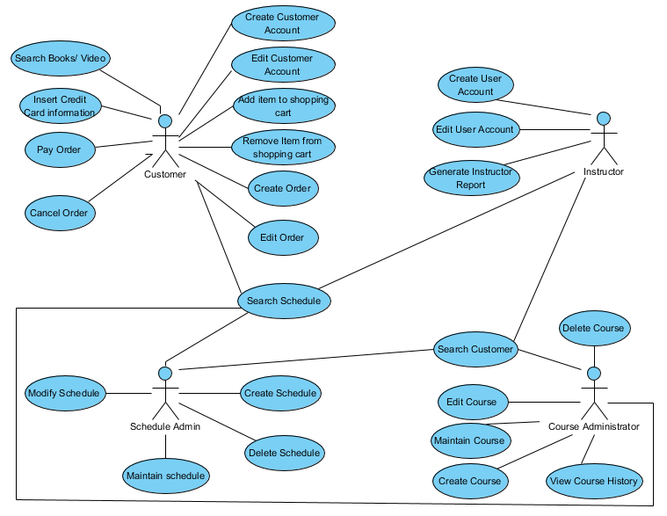

2.2 Use Case Diagram Description
The system use case diagram described all actions undertaken by each actor (users) in a system. In OTOT system, the actors are a customer, Instructor, course administrator, and schedule administrator. From the ITOT use case diagram, the customer can create a customer account, edit customer account, add item to shopping cart, Remove item from shopping cart, create order, edit order, search schedule, Search book/ video, pay order and cancel order. Schedule admin can create schedule, modify schedule, search schedule, and maintain schedule. Instructor can create user account, edit user account, Search customer, search schedule, and generate instructor report. Course administrator can Search customer, create course, edit course, maintain course, delete course, view course history, and search schedule.

2.3 List of Actors and Definitions

Actor Name | Definition
Customer | A Customer is a person who purchases ITOT products.
Instructor | An instructor is a person that provide the product contents and learning support.
Course administrator | A course administrator is a person that manages all courses offered in ITOT.
Schedule Administrator | A schedule administrator is a person that manages all schedules in ITOT.
Other administrators | Other administrators are people able to manage specific areas like shopping cart management.
Credit card service | Credit card service is a system that links ITOT to credit card service.
Accounting System service | An accounting system service is a system that links ITOT to accounting service for the transfer of customer information.
Shopping cart | A shopping cart is a system that allows purchasing of products in ITOT

2.4 List of Use Cases and Description
Use Case Name | Description
Create Customer | This use case creates a new Customer including customer id, first and last name, address, phone numbers for work and cell phone.
Maintain customer credit card information | This use case maintains customer’s credit card information including for each credit card including account number, account name, expiration date, and security code.
Search Customer | This use case searches and display customer information by instructors, course administrators, schedule administrators, and other administrators.
Maintain course | This use case create, edit or delete course information including course number, course title, course description, course type, course duration, course start date, course end date, course prerequisites, CEU credits, and course fee.
Maintain books | This use case creates, edit or delete book information including title, authors, date, edition, and ISBN.
Maintain video | This use case create, edit or delete video information including video id, video name, and video fee
Search course | This use case search for courses based on title, category, popular course, recent releases, planned courses.
Create instructor | This use case create a new instructor including instructor id, instructor first and last name, address, cell and home phone, areas of teaching expertise, bio, and stipend.
Generate instructor report | This use case generate reports of instructor schedules and courses taught
Maintain schedule | This use case create, modify, and delete course schedule information including course title, course number, course description, course prerequisites, course type, length of course, course outline, schedule dates, and instructor information.
Search schedule | This use case search schedule based on keyword, title, and schedule.
Display shopping cart items | This use case display available shopping cart including quantity, item number, item name, cost, shipping, coupons, discount, and total.
Manage shopping cart | This use case manages shopping cart t including increasing the number of items, removing items, calculating shipping costs and applying coupons and discounts.
Generate a completion certificate. | This use case generates and print certificate of completion.
Manage users | This use case creates, edit or delete all user details who access the system.

3. Detailed Use Case and Activity Diagram
This section dwells on detailed actions done by all actors. The flow of activities handled in by users/actors are discussed in details.

3.1. Manage shopping cart Use Case

3.1.1. Manage shopping cart Use Case Description/Scenario

Manage shopping cart use case involve different functions that can be undertaken. The customer login to the system and shopping cart system displays the available items (products) to the customer. The customer is can add the item into the shopping chart, can increase or decrease the number of items selected, can remove an item, and can also place or cancel an order. The shopping cart allows the customer to calculate the shipping cost while placing an order and applying coupons. For payment purpose, the customer is allowed to select the payment method of their choice and finally process payment.

3.1.2 Shopping cart Use Case Detailed Steps

Use Case and History
Use Case ID: |  |  | Use Case Name: Manage Shopping Cart
Created By: | Date Created: | Last Updated By: |  | Date Last Updated:

Actors, Description, Preconditions, Postconditions
Actors: | Shopping chart  Customer
Description: | The process of purchasing a product from ITOT using shopping cart system
Preconditions: | User/customer must be logged in
Postconditions: | Customer accounts and transactions are balanced, communication with account system is reinitialized, and finally, communication is made to a customer of purchase success or failure.

Normal Path
User Action | System Action
1. This use case begins when the customer browses to shopping chard module. | 2. the shopping cart provides the Item available which lists each item in the Shopping Cart including quantity, item number, item name, cost, shipping, coupons, discount, and total. The customer can access the items from here.
3. Customer chooses the item of their choice and press to add. | 4. The shopping cart adds the item to the customer’s shopping cart list.
5. Customer chooses an item from that He/ She wish to remove from the shopping list and press remove. | 6. The shopping cut removes the item from customers shopping list as requested.
7. Customer request for order placement when done selecting the item. | 8. The shopping cart place customers order successfully.
9. Customer request to Cancel or Pay order. | 10. If customer request cancels the order, the system cancels the order as requested. If customer request to pay order, the shopping cart displays payment method choices.
11. The customer selects the payment mode. | 12. The shopping cart requests the for payment method details.
13. The customer provides the requested details. | 14. The payment is done if the provided information is correct, and the customer is notified with success of failure note.

Alternative Path
User Action | System Action
 | In #13 above, if customer has not provided payment details, the system display error message “ Please provide payment details ”
 | In #14 above, if payment details check to return false, the system display captured error message “ error ”

Use Case Related System Issues
Exceptions: | Other payment methods are not allowed — only Credit card.
Includes: | Include.
Priority: | Use of credit cards.
Frequency of Use: | No limit.
Business Rules: | Not set.
Special Requirements: | None.
Assumptions: | Every customer is computer literate.
Notes and Issues: | None

3.1.3 Shopping cart Form/Screen Mockup and Dialog
Shopping cart screen mockup
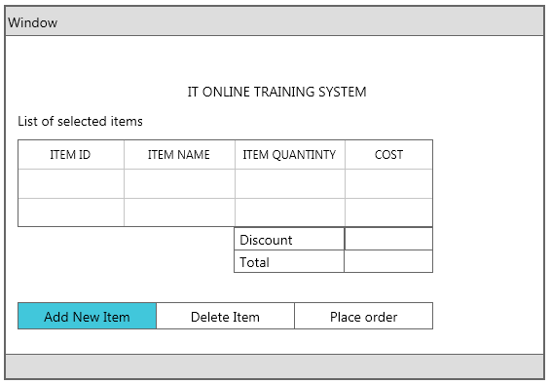
This image shows the shopping cart in the customer’s screen. The table displays all selected items by the customer including the item id, item name, item quantity, and cost. If there is any discount, it is displayed. The system calculates the total and display on the shown text field. This screen has three buttons. The Add New Item button is clicked to add a new item to the list. Once the customer clicks this button, a new window with a list of available products is prompted, and the customer can select the item of their choice from there. Delete item button is used to remove the selected item from the list. Place order button is clicked to place orders.

Orders list screen mockup
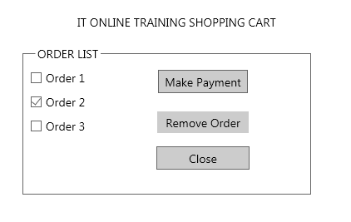
Orders list screen has a list of orders as shown. The user selects the orders wanted and clicked the button of choice to perform the desired action. The user can make payment, remove selected orders or close the window.
Payment screen mockup
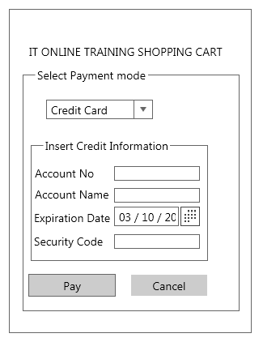
When customer click makes payment button from the previous screen, the payment screen pop out. As shown the customer select payment mode and for this case, the credit card is selected. The user then inserts account number, account name, expiration, and security code. Then the pay button is clicked to make payment. The cancel button is used to abort the process.

Payment confirmation screen mockup
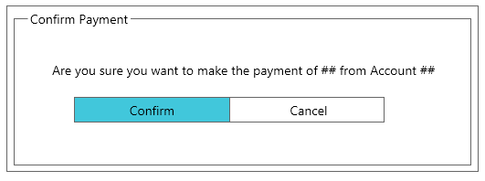
The confirm payment screen allows the user to either click confirms button to allow payment or cancel button to cancel the transaction.

3.1.4 Activity Diagram for Use Case Manage shopping cart and Discussion

Activity Diagram for Use Case Manage shopping cart
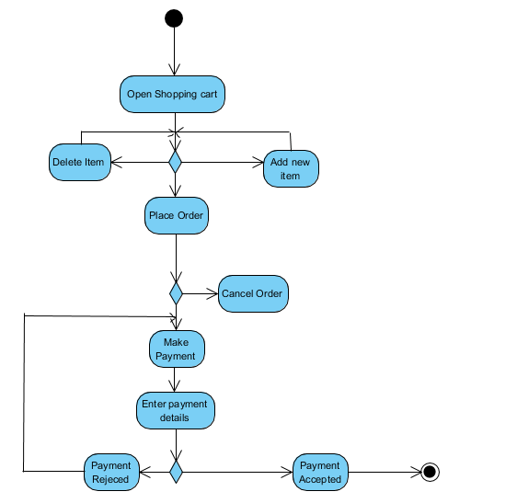

Discussion
The activities start by opening the shopping cart. Once the shopping cart is open, the selected items are displayed and if there is none the user has a chance to add the item. The user can also delete the item, and once deletion is done, the system gets refresh and reopen the cart. If user place order, the user can proceed to payment or cancel the order. User input the credit card. If the credentials are rejected, the system goes back to the payment screen. If the details are accepted, the payment is done, and the process ends.

4. Domain Class Diagram
This section describes all the classes in ITOT, including each class attributes, Functions or method in each class. The section also shows how classes relate to each other and their association.

4.1 Domain Class Diagram(s)
Class Diagram.
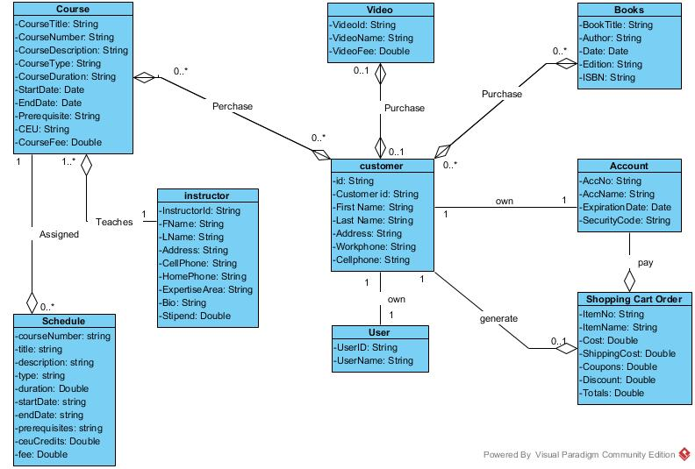

4.2 Class and Relationship Analysis

Class and Relationship Analysis
Class Name 1 | Relationship with Multiplicity | Class Name 2
Instructor | An Instructor teaches zero or more (0..*) Course  A Course is taught by a single (1) Instructor | Course
Customer | A Customer purchases Zero or more (0..*) Course  A Course Purchased by Zero or more (0..*) Customer | Course
Customer | A Customer purchases Zero or more (0..*) Book  A Book Purchased by Zero or more (0..*) Customer | Book
Customer | A Customer purchases Video  A Video Purchased by Zero or more (0..*) Customer | Video
Customer | A Customer own one (1) Account  An Account owned by one (1) Customer | Account
Customer | A Customer own one (1) User  A User-owned by one (1) Customer | User
Customer | A customer owns Zero or more (0..*) Shopping Cart.  Shopping Cart owned by one (1) customer | Shopping Cart Order
Schedule | A schedule assigned to one (1) course  A course assigned to Zero or more (0..*) schedule | Course
Account | An Account pays zero or more (0..*) Shopping Cart  A Shopping Cart is paid by a single (1) Account | Shopping Cart Order

4.3 List of Classes with Definitions, Attributes, and Operations

Classes, Attributes, Operations, Requirement
Class  Name | Class Definition | Attributes | Operations | Requirement  Number
Customer | A Customer is a person or organization where an Account exists to access ITOT products. | customerID: string  firstName: string  lastName: string  address: string  workPhone:string  cellPhone: string | createCustomer()  readCustomerID()  readFirstName()  modifyFirstName(firstName)  readAddress()  modifyAddress(address)  readWorkPhone()  modifyWorkPhone(workPhone)  readCellPhone()  modifyCellPhone(cellPhone)  removeCustomer(customerID) | REQF2.1
ScheduledCourse | A ScheduledCourse is a course offered by ITOT at a specific date and time. | courseNumber: string  title: string  description: string  type: string  duration: number  startDate: string  endDate: string  prerequisites: string  ceuCredits: number  fee: number | createScheduledCourse()  readCourseNumber()  modifyCourseNumber(courseNumber)  readTitle()  modifyTitle(title)  readDescription()  modifyDescription(description)  readType()  modifyType(type)  readDuration()  modifyDuration(duration)  readStartDate()  modifyStartDate(startDate)  readEndDate()  modifyEndDate(endDate)  readPrerequisites()  modifyPrerequisites(prrequisites)  readCeuCredits()  modifyCeuCredits(ceuCredits)  readFee()  modifyFee(fee)  RemoveScheduledCourse(courseNumber) | REQF3.1
User | A User is a person who has credentials to access the ITOT system | username:string  password: string | login(username, password)  logout()  readUsername()  modifyUsername(username) | REQF9.1
Instructor | An instructor is a person or organization where an Account exists for the purpose offering training services in ITOT products. | instructorID: string  firstName: string  lastName: string  address: string  cellPhone:string  homePhone: string | createInstructor()  readinstructorID()  readFirstName()  modifyFirstName(firstName)  readAddress()  modifyAddress(address)  readcellPhone()  modifycellPhone(cellPhone)  readhomePhone()  modifyhomePhone(homePhone)  removeInsrtuctor(instructorID) | REQF4.1
Course | A Course is a product offered in ITOT system | courseNumber: string  courseTitle: string  courseDescription: string  coursetype: string  courseduration:number  startDate: Date  endDate: Date  prerequisite: string  cueCredit: string  courseFee: Number | createCourse()  readcourseNumber()  readCourseTitle()  modifyCourseTitle()  readCourseDescription()  modifyCourseDescription()  readcourseType()  modifyCourseType()  readCourseDuration()  modifyCourseDuration()  readStartDate()  modifyStartDate()  readEndDate()  modifyEndDate()  readPrerequisite()  modifyPrerequisite()  removeCourse(customerID) | REQF3.2
Book | A book is a product offered in the ITOT system for access by users and other classes | bookTitle: string  author: string  date: string  edition:number  isbn: Sting | createBook()  readBookTitle()  modifyBookTitle()  readAuthor()  modifyAuthor()  readDate()  modifyDate()  readEdition()  modifyEdition()  readISBN()  modifyISBN()  removeBook() | REQF3.4
Video | A video is a product offered in the ITOT system for access by users and other classes | videoID: string  name: string  fee: number | createVideo()  readVideoID()  readname()  modifyname()  readfee()  modifyfee()  removeVideo() | REQF3.3
Shopping cart | A shopping cart is an object that allow customer purchase items from ITOT system | itemNumber: string  itemname: string  quantity: number  cost: number  shipping: string  coupons: number  discount: number  total: number | createShoppingCart()  readItemNumber()  readquantity()  modifyiquantityr()  readitemname()  readcost()  readdiscount()  readcoupon()  calculateTotal()  readtotal()  modifytotal()  removeshoppingcart() | REQF6.2
Account | Account is an object the enable payment or financial transactions in the ITOT system | accountNumber:String  accountName:String  expirelyDate:string  securityCode:string | createAccount()  readAccountNumber()  modifyAccountNumber()  readAccountNamey()  modifyAccountName ()  readExpirelyDate()  ModifyExpirilyDate()  readSecurityCode()  ModifySecurityCode()  removeAccount() | REQF2.2

4.3.1 List of Classes, Attributes, Operations, and Requirement Number Discussion
The list of classes involved is customer class, ScheduleCourse class, user class, instructor class, course class, book class, video class, shoppingcart class, and accounting class. Each class attributes (variables) are listed with their data type. Each class has different operations (functions /methods) without parameters. The requirement number for every class is indicated in the last column.

4.4 Domain Class Diagram Discussion
The domain class diagram is showing different classes with their attributes. The detailed relationship between the classes is also indicated in the diagram.

5. Domain State Diagram
This section describes the states that specific objects can attain indicating the transition between the states. The specific class discussed in this section is the shopping cart class.

5.1 Shopping cart State Diagram and Discussion
Shopping cart state diagram
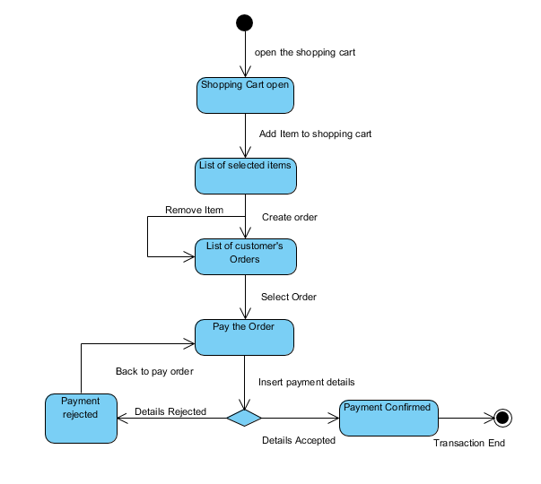

State Diagram Discussion.
The shopping cart state diagram above describes all possible states that this class objects can attain. Once the shopping cart opens, the user can add an item in the selected item list or can remove the item from this list. After selecting the items, the customer creates the order, and the order list is displayed. The customer can delete an order and order list is refreshed and displayed again. Customer proceeds to payment and is required to insert credit card details. The details can be accepted or rejected. If the details are rejected, the system goes back to make payment state. If details are accepted, the payment is confirmed, and the process ends.

6. Sequence Diagrams

6.1 System Sequence Diagram (SSD) for <Use Case Name> Use Case and Description
<Replace <Use Case Name> above with the name of your detailed Use Case like Manage Shopping Cart so that it reads like System Sequence Diagram (SSD) for Manage Shopping Cart Use Case.

1. Insert a description of your SSD.

2. Insert a UML System Sequence Diagram (SSD) for your use case from Section 3 above. An SSD shows the actor and the System and the messages (including message name and parameters) required to implement the detailed use case description from Section 3. The SSD shows the inputs and outputs to/from the system for the use case.>

6.2 Detailed Sequence Diagram for <Use Case Name> Use Case and Discussion
<Replace <Use Case Name> above with the name of your use case like Manage Shopping Cart so that it reads like Detailed Sequence Diagram for Manage Shopping Cart Use Case and Description.

1. Insert a UML Detailed Sequence Diagram for your use case. A Detailed Sequence diagram shows the actor and instead of the System like in the SSD, it will show all of the objects (instances of classes) that are required to implement the use case. Your Class Diagram will be helpful here. The net messages should be the same as in your SSD above but you will have more detailed messages including message name and parameters among the different objects that are actually required to implement the use case. So now you will add objects across the top of your diagram and omit System. Include a discussion of your Detailed Sequence Diagram.>

2. Insert a discussion of your Detailed Sequence Diagram.

Appendix.

<Insert other material you feed is relevant to the project.>

